Software Design Specification

< MotorBike Karobar>

Project Code: CMP-4970

Internal Advisor:

External Advisor:

Project Manager: Saad Razzaq

Project Team: 1: Muhammad Asad Waqar(BSCS-F17-38)(Team Leader)
2: Saad Bin Aslam(BSCSF17E026)

Submission Date:

Table of Contents
1: Introduction
1.1Purpose of document
1.2 Project Overview
1.3 Scope
2: Functional Requirements
2.1 Non-Functional Requirements
a) Performance Requirements
b) Security Requirements
c) User Documentation
3: Overall System Description
3.1 User Characteristics
3.2 External Interface Requirements
4: System Architecture
4.1 Use Cases
5: Detail System Design
5.1 Activity Diagram for seller
5.2 Activity Diagram for purchaser
5.3 ER Diagram
5.4 Class Diagram
6: Project Methodology
7: High Level Plan
8: References

Introduction

  - Purpose of Document
The purpose of this document is to give a detailed description of the requirements for the “MotorBike Karobar” website. It will illustrate the purpose and complete declaration for the development of system. It will also explain system constraints, interface and interactions with other systems. This document is primarily intended to be proposed to a customer for its approval and a reference for developing the first version of the system for the development team
  - Project Overview
There is no good digital platform for selling and purchasing of new & used motorbikes, their parts & accessories. We have seen the rush of people present at the specified workshops for purchasing motorbikes and related parts. Lot of people present for reviewing & purchasing and there is no proper place and arrangement, also no good communication system b/w customer and seller. Also there is no price justification system. And if some individual want to sale his/her motorbike then he/she has to face a lot of difficulties like first take his/her bike to some workshop and then there is no management.

There is some, actually I will say a lot of work has been done in this domain but there are lot of things which remains unnoticed and also those works are either very complex for local audience or this domain is a single limited option in some other big domain’s platform which is still a big problem
Like there are two big platforms which are working in this domain in Pakistan :
- PAKWHEELS.COM is a big platform which is dealing with car business and motorbikes business. And their focus is mostly on cars. Basically divided focus and no system for any individual to sell bike. Also that platform is very complex for local audience and not good in design, in short very unattractive to navigate and spend time on that platform.
- MOTORCYCLE SHOP is another platform which targets only motorbikes business which is good but there is no system for selling and purchasing of used bikes. Also no system for uploading other than platform’s owner or management. And also no system for any individual or workshop to grow their business on their own.
- All other platforms are motorbikes official companies owners official websites which are limited and main thing is that not solving our problems.

. So, in short there is no digital combined platform for this problem and these are all the main hurdles which people face. Now we provide a single specific platform of this domain which deals with all these problems which remains unnoticed and deals with each & everything which can be possible .

  - Scope
(Functionalities system will perform)

MotorBike Karobar will provide a platform for purchasing & selling of motorbikes, their parts & accessories, which can be either new or used.
Everybody can upload his/her bike & parts with all info and status, which can be some workshop, organization or any individual.
One side for navigating platform for purchasing and One side for uploading for selling means.
Proper communication system to contact on both sides.
This will provide a platform where you can do 80% of work of this domain while sitting freely anywhere.

(Functionalities system will not provide)

MotorBike Karobar will not provide online transaction between two sides.
MotorBike Karobar will not provide pick and drop system.
MotorBike Karobar will not provide personal level legalities of purchaser & seller.

- Functional Requirements
- Login/Credentials
If its admin or a user, all must have to create their account and enter required data for further processing.
Name, Contact No, Email, Residence

- Selling Side for Bikes
A selling side for the users who want to sell. They will provide each and everything which a purchaser can demand.
For selling, they must have to upload some information like Bike’s condition, Engine Condition, Old or New, Company’s Name, Price, Chassis Number.

- Selling Side for Bikes parts/Accessories
People who wants to sell the Bikes parts & accessories can easily post their content here.
- Purchasing Side
A purchasing side for the users who want to navigate and purchase. Everything must be visible according to location.
They can navigate throughout the page to purchase what they actually need.

- Purchasing Side for Bikes parts/Accessories
People who wants to purchase the Bikes parts & accessories can easily navigate here
and purchase according to their need

- Contact
A contact side where users can communicate with each other for buying or purchasing means.

2.1 .Non-functional Requirements
  - Performance Requirements
- Scalability
MotorBike Karobar website needs to be scalable so if we want to add a new function or feature it can be added easily.

- Availability
MotorBike Karobar requires high availability in the monitoring and controlling, communication and should be available 24/7.

- Reliability
MotorBike Karobar requires an appropriate level of reliability in technologies, devices, communication and services.

  - Security Requirements
- Security requirements can be studied by examining the overall process. When a user wants to login their Account, Admin will Authenticate their information which is given by the user in the signup time, after that, the admin will permit login.
- And also to check for illegal posts which are not related.

  - User Documentation
This is a Student Project so there is no User Documentation and User Manual.

- Overall System Description
This section will give an overview of the whole system. MotorBike Karobar will be explained in its context to show how the system interacts and introduce the basic functionality of it. It will also describe what type of stakeholders that will use the system and what functionality is available for each type. At last, the constraints and assumptions for the system will be presented.

  - User characteristics
- Administrator
MotorBike Karobar administrator is given specific permission for managing, maintaining and controlling the system.

- User
Someone who interacts with the website. User could be seller or purchaser, motorbike’s organization owner or some common man.

Operating environment
- Android
MotorBike Karobar is compatible with all android versions.

- IOS
MotorBike Karobar is compatible with all IOS versions.

- Windows
MotorBike Karobar also runs on all windows versions.

- Browsers
MotorBike Karobar supports all browsers and search engines with all versions.

System constraints
- GPS
MotorBike Karobar will provide data to navigate according to location bases. So, of course GPS is a constraint. Since there are multiple systems and multiple GPS manufacturers, the interface will most likely not be the same for every one of them.

- Internet
Internet connection is also a constraint for the system. Since the website fetches data from the database over the Internet, there must be an active Internet connection for the system for its proper functionality.

- User Data
User data is also a constraint. Users have to enter data either it is for selling purpose or purchasing.

3.2: External Interface Requirements
Hardware Interfaces
MotorBike Karobar is a website which runs on any kind of device which supports web browsers or search engines. So, there is no need of any kind of special hardware.

Software Interfaces
- Login Interface
- Contact
- Selling Side
- Purchasing/Navigation Side
- Location Interface

4. System Architecture

4.1Use Cases

Use Case Diagrams

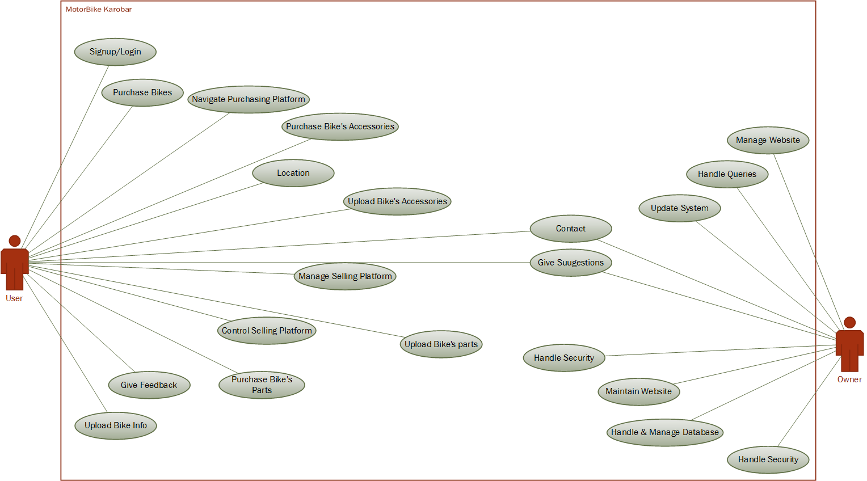

Use Case Description
Each Use Case has a description, which describes the functionality that will be built in the proposed system. The template for Use Case description is given below:

1: Signup/Login
Actors: Users
Feature: Authentication
Use case Id: |  | 1
Pre-condition: |  | User should have internet connection and open Website
Scenarios
Step# | Action |  | Website Reaction
 | If user wants to signup |  | Website directs to the signup page & demands required info
2. | If user wants to log in |  | Log in page displayed. first have to sign up and then provide required info needed to authenticate
Post Conditions
Step# | Description
- Signup | Give info and redirect to login page
- Login | Login the user with its Privileges and redirect to home page

2: Purchase Bikes, parts & accessories
Actors: User
Feature: User can purchase bikes. Bike’s parts & accessories
Use case Id: |  | 2
Pre-condition: |  | User should have internet connection and click on purchasing platform
Scenarios
Step# | Action |  | Software Reaction
1. | If user wants to purchase bike |  | Website directs user to purchasing platform and further on location oriented stuff
2. | If user wants to purchase bike’ part |  | Directs to purchasing platform and then further on location oriented stuff
3. | If user wants to purchase bike’ accessory |  | Directs to purchasing platform and then further on location oriented stuff
5. | If user just wants to navigate |  | New content is keep displaying

3: Sell Bikes, parts & accessories
Actors: User
Feature: Users can sell bikes, bike’s parts & accessories
Use case Id: |  | 3
Pre-condition: |  | User must be logged in, bike, bike’s part or accessory and click on selling platform
Scenarios
Step# | Action |  | Software Reaction
1. | If user wants to sell bike |  | Website directs user to selling platform and further into uploading page and then bike is added on their inventory
2. | If user wants to sell bike’s parts |  | Directs to uploading page and then part is added on their inventory
3. | If user wants to upload bike’s accessories |  | Directs to uploading page m and then accessory is added on their inventory
4. | If user upload bike accessories |  | Accessories are added on his gig

4: Contact
Actors: User & Owner/Administration
Feature: Users can contact each other for communication means, owner can handle contact us page and can even contact users
Use case Id: |  | 4
Pre-condition: |  | User must be login to contact. And clicks on contact.
Scenarios
Step# | Action |  | Software Reaction
1. | If user wants to contact the seller |  | Provides the contact info of that seller which seller provides on his gig
3. | If user wants to contact owner |  | Website provides contact us page to the user
4. | Owner wants to contact some account |  | They explore the database of that user

5: Location
Actors: User
Feature: users can get location oriented content
Use case Id: |  | 5
Pre-condition: |  | User must enable location of the device
Scenarios
Step# | Action |  | Software Reaction
1. | If user wants to add location or want location oriented content |  | Website provides user current location or location they want to choose

6: Suggestions & Feedback
Actors: User
Feature: Users can give suggestions and feedback about website and its functionality
Use case Id: |  | 6
Pre-condition: |  | User must be logged in
Scenarios
Step# | Action |  | Software Reaction
1. | If user wants to give suggestions |  | Directs user on suggestions page
2. | If user wants to give feedback |  | Directs user on feedback page

7: Handle Security & Queries
Actors: Owner
Feature: Owner can handle security concerns and queries
Use case Id: | 7
Pre-condition: | Owner credentials
Scenarios
Owner handles the security concerns by keeping him up to date
Owner handle queries given by users

8: Update System & Maintain website
Actors: Owner
Feature: Owner can keep the system Up to date and can manage overall website features
Use case Id: | 8
Pre-condition: | Owner Credentials
Scenarios
Owner keeps the system up to date
Owner maintains overall websites functionality and features

9: Update Database
Actors: Owner
Feature: Owner can update and manage the database
Use case Id: | 9
Pre-condition: | Owner Credentials
Scenarios
Owner will manage all the database of users either they are buyer or seller
Owner will update the database schemas

5.Detail System Design
5.1Activity Diagram for seller:

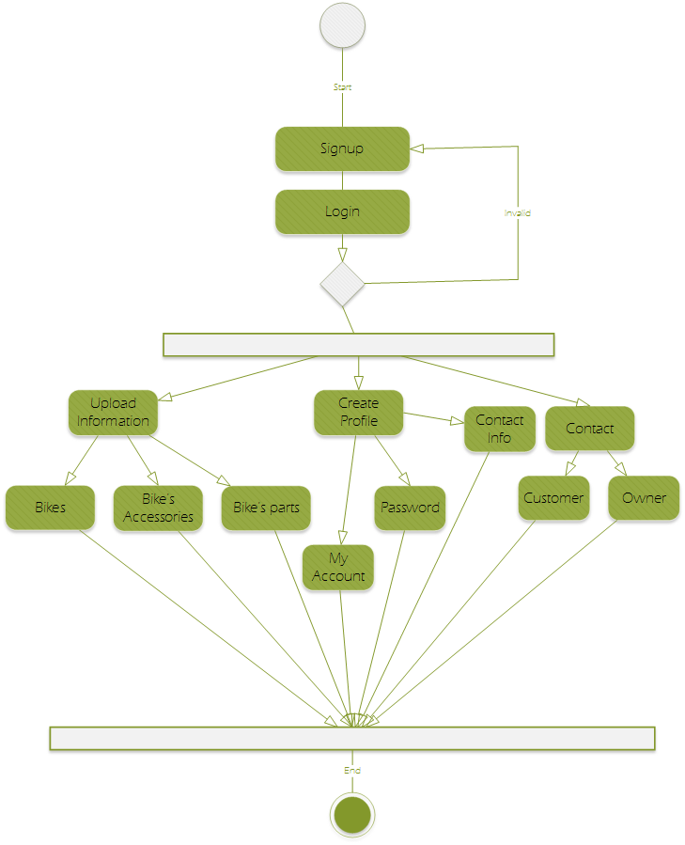

5.2Activity Diagram for purchaser:

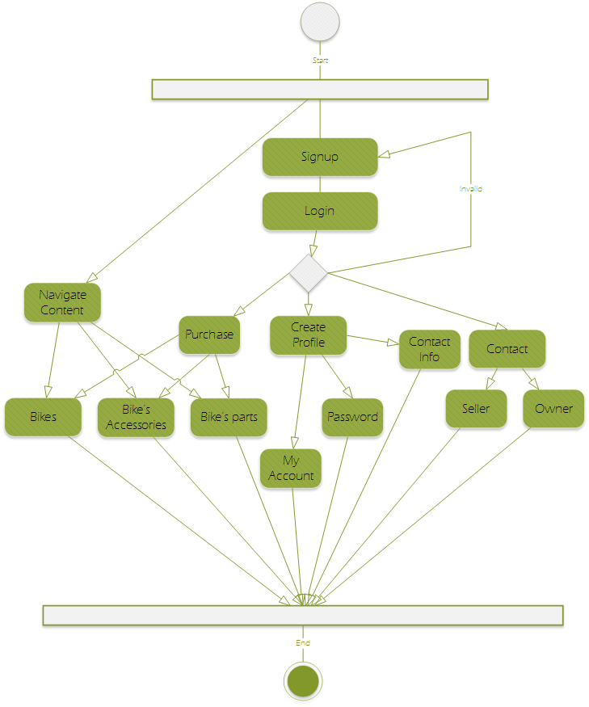

5.3ER Diagram:

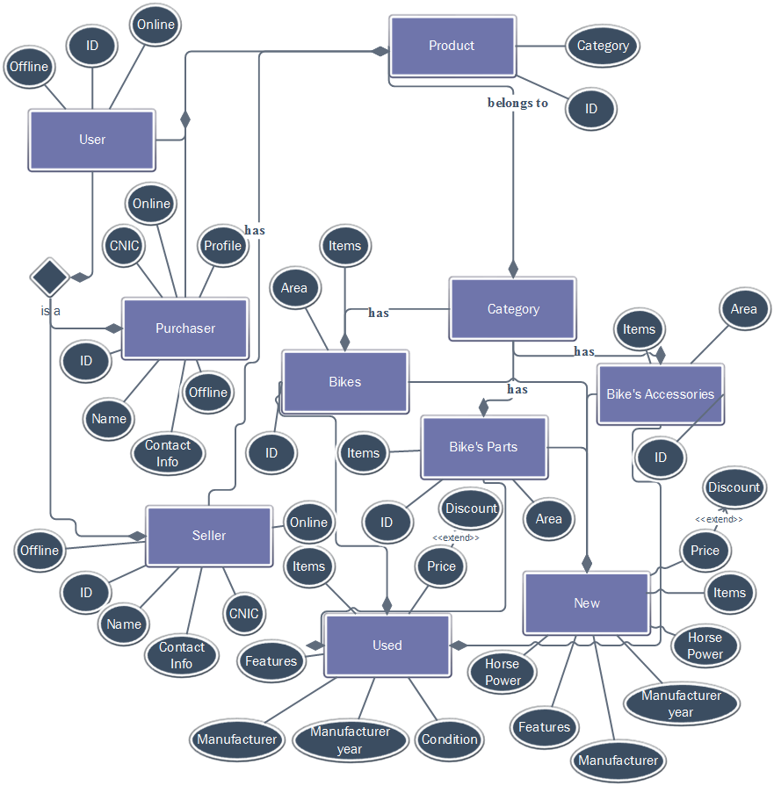

5.4Class Diagram:

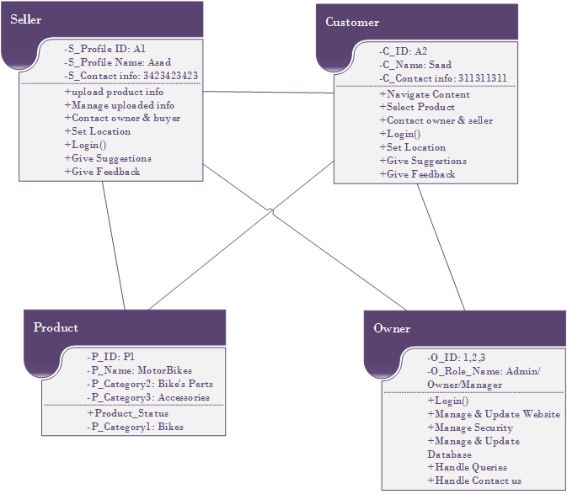

.

6: Project Methodology
In this project we are going to use Modified Waterfall SDLC Model. The following figure is showing the phases which we will use to develop our
project. This model is consisting of six phases.

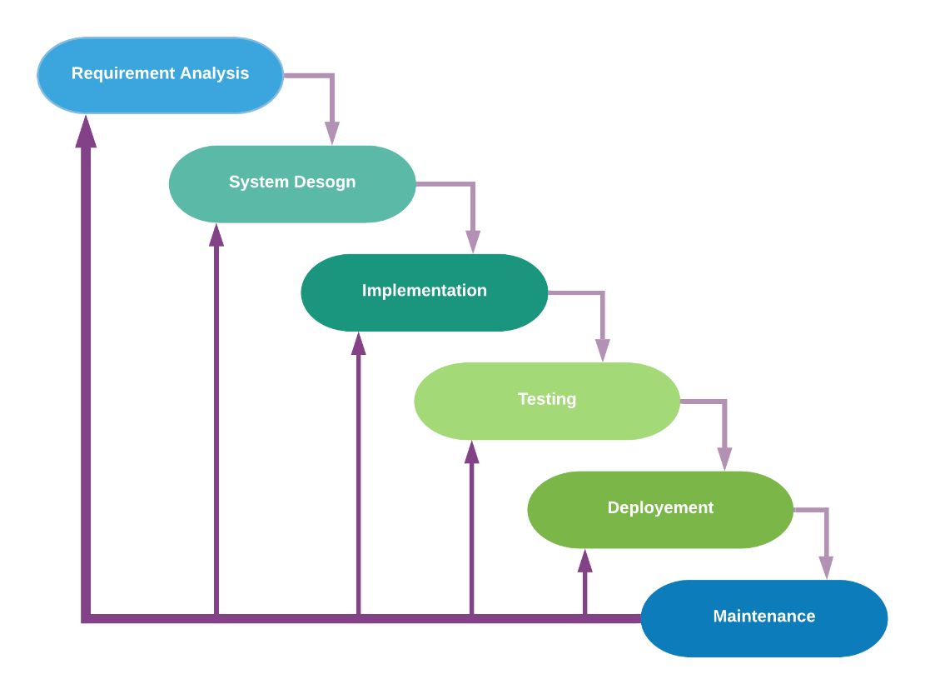

- Requirements Analysis: The first phase involves understanding what needs to design and what is its function, purpose, etc. Here, the specifications of the input and output or the final product are studied and marked.
- System Design: The requirement specifications from the first phase are studied in this phase and system design is prepared. System Design helps in specifying hardware and system requirements and also helps in defining overall system architecture. The software code to be written in the next stage is created now.
- Implementation: With inputs from system design, the system is first developed in small programs called units, which are integrated into the next phase. Each unit is developed and tested for its functionality which is referred to as Unit Testing.
- Testing: All the units developed in the implementation phase are integrated into a system after testing of each unit. The software designed, needs to go through constant software testing to find out if there are any flaw or errors. Testing is done so that the client does not face any problem during the installation of the software.
- Deployment: Once the functional and non-functional testing is done, the product is deployed in the customer environment or released into the market.
Maintenance: This step occurs after installation, and involves making modifications to the system or an individual component to alter attributes or improve performance. These modifications arise either due to change requests initiated by the customer, or defects uncovered during live use of the system. The client is provided with regular maintenance and support for the developed software.

High level Plan and References are as below :

7: High level Project Plan

Column1 | Column2 | Column3
 | Textile Auxiliaries
Task | Start Date | Days to Finish
Requirements | 31-Oct-21 | 15
Research | 15-Nov-21 | 10
Planning | 23-Nov-21 | 8
Design 1 | 01-Dec-21 | 20
Design 2 | 22-Dec-21 | 20
Design 3 | 15-Jan-22 | 20
Design 4 | 06-Feb-22 | 20
Development | 01-Mar-22 | 30
Testing | 02-Apr-22 | 10
Maintain | 13-Apr-22 | 10
Following are the high-level plan of our project. We set the timeline of project from the

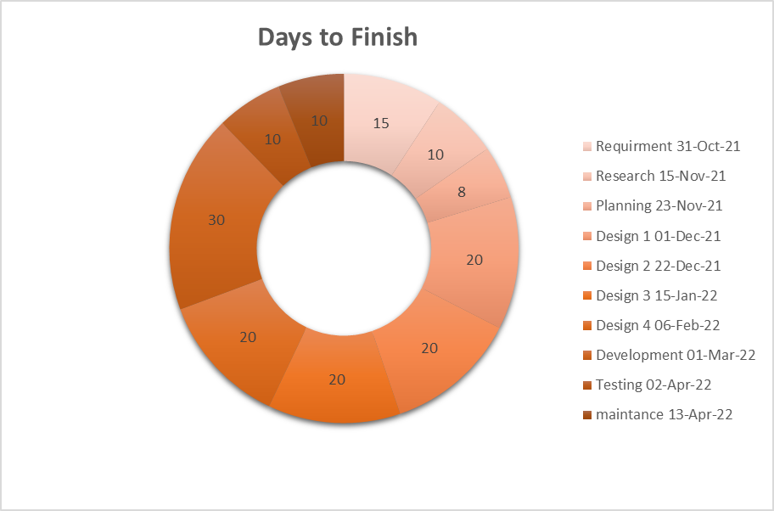

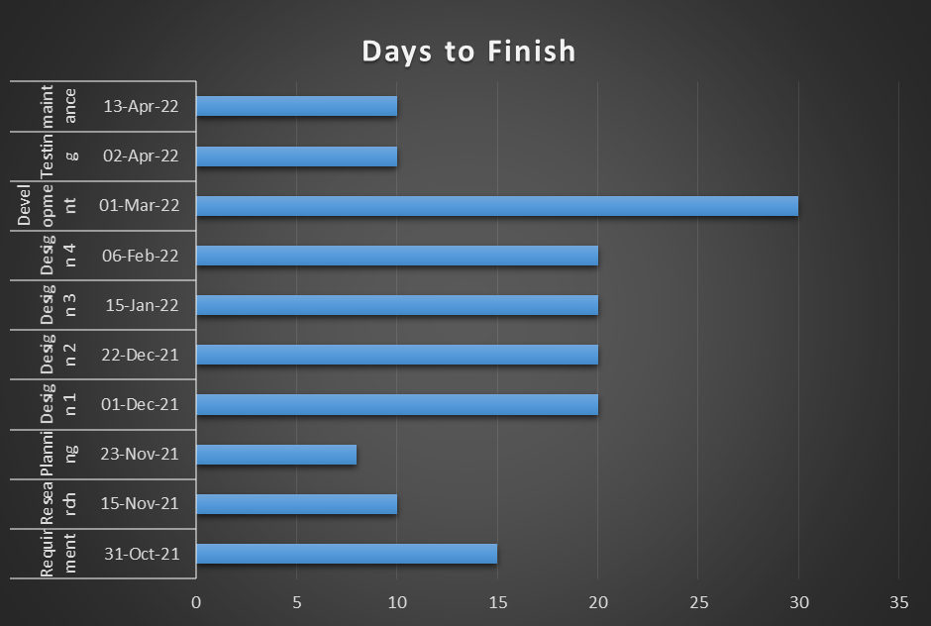

8: References
Websites already working in this domain:

- PAKWHEELS.COM
- MOTORCYCLE SHOP

A senior friend who has some expertise in web development.

Project Supervisor is still not found. We will definitely discuss with him and ask for more improvements & expertise.

